


APPLICATION FORM
Competitor first and last name

Date and place of birth Address

Telephone No. E-mail
- I want to play at the final concert
- I do not want to play at the final concert Program: Composer (first and last name, Title)

Parent or. Guardian′s signature

APPLICATION FEE (3 lessons)
  - active participation 300 EUR
  - guest 50 EUR
With application, send your CV.

Application sent no later than April 20, 2026,
With proof of payment of 150 EUR – application fee,
The number of places is limited!

The rest of the course fee 150 EUR has to be paid

till May 20, 2026 to the following address and account:
Gallus J. Carniolus zavod, Metelkova 6, 1000 Ljubljana, Slovenija by adding
»International Summer School Flute«
IBAN: SI56 0201 1001 4358 924
BIC/SWIFT: LJBASI2X, Bank: NLB Ljubljana
Reference: SI00 01072026

Additional Information: info@gallus-zavod.sii ravnateljica@glasbena-sb.si



Razpis nagradne štipendije

Na naslov Martinbelic1@googlemail.com pošlji video s svojo kratko predstavitvijo in posnetkom solo skladbe
E.Bozza »IMAGE za flavto solo«. Izbranemu udeležencu-ki bomo podelili nagradno štipendijo v višini 500 € in mu/ji omogočili koncert v okviru programa Ustanove Gallus. Nagrajenca-ko bomo razglasili na zaključnem koncertu 6. Julija 2026.

Call for prize scholarship

Send your short presentation and a video recording of IMAGE for Flute Solo by E. Bozza to
Martinbelic1@googlemail.com .
The selected participant will be awarded a prize scholarship of EUR 500 and will have the opportunity to attend a concert in the framework of the Gallus Foundation programme. The winner will be announced at the closing concert on 6th July 2026.

Ključno poslanstvo Ustanove Gallus je vsestranska podpora mladim glasbenim talentom in projektom, za katere verjamemo, da imajo možnost mednarodne uveljavitve. / The Gallus Foundation’s mission is a professional, versatile, far-reaching support of young talented musicians and artistic projects, which have a possibility of international acclaim.




Občina Slovenska Bistrica

14. Mednarodna poletna šola flavte
14th International Flute Masterclass

MARTIN BELIČ

Profesor na / Professor at

LMC University Augsburg

Asistent solo flavtist / Co-Principal Flutist

Münchner Philharmoniker

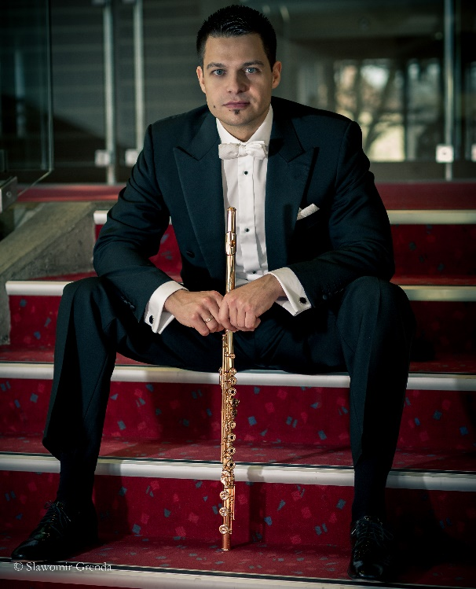

1. 7. – 6. 7. 2026
Glasbena šola / Music School Slovenska Bistrica, Slovenija

Martin Belič je mednarodno priznani slovenski flavtist, čigar umetniški talent združuje tehnično briljantnost z izrazitim liričnim tonom. Od leta 2007 živi v Münchnu, kjer je namestnik solo flavtist Münchenskih filharmonikov pod vodstvom Lahava Shanija in profesor na Leopold Mozart College of Music univerzi v Augsburgu, ter docent pri Zvezi bavarskih godb. Njegov kultiviran ton, izrazno fraziranje in širok repertoar so ga uvrstili med najbolj priznane flavtiste svoje generacije.

Po opravljeni maturi na Konservatoriju za glasbo v Mariboru pri prof. Violeti Ozvatič je diplomiral na Mozarteumu v Salzburgu pri prof. Herti Mergl in prof. Ireni Grafenauer, pri kateri je leta 2007 z odliko magistriral na koncertni smeri in nato zaključil podiplomski študij pri prof. Michaelu Martinu Koflerju. Bil je Zoisov štipendist in štipendist Ministrstva za kulturo Republike Slovenije, podjetja SMART-COM, Rotary kluba Ljubljana, Ustanove Gallus in fundacije “Live Music Now”, ki jo je v Salzburgu ustanovil Yehudi Menuhin. Je prejemnik nagrade dr. Romana Klasinca za izjemne glasbene dosežke, Gallusov varovanec od leta 2000 in od leta 2023 prvi nosilec naziva Gallusov ambasador ter aktiven podpornik mladih glasbenih talentov.
Osvojil je več prvih nagrad na slovenskih in mednarodnih tekmovanjih v Italiji, Avstriji in Nemčiji, na TEMSIG-u in mednarodnih tekmovanjih Cittá di Pietra Ligure, Intermusica Birkfeld in Theobald Böhm, kjer zdaj redno deluje kot predsednik in član žirije.

Poleg solističnih koncertov in komornih recitalov je snemal in koncertiral še s Simfoničnima orkestroma Slovenske filharmonije in SNG Maribor, Simfoniki RTV Slovenija, Zagrebškimi filharmoniki, madžarskim Mendelssohn Chamber Orchestra, Ensemble Dissonance, Orkestrom Amadeo, idr. Redno deluje kot gost v orkestrih na Bavarskem, v Kölnu, Salzburgu in Würtenbergu.

Diskografija: CD »Zelenci«, Bizet-Bornejeva Briljantna fantazija na temo »Carmen« z Mariborsko filharmonijo (Založba Gallus, 2005), CD Mladi virtuozi 1, C. Nielsnov Koncert za flavto s Simfoniki RTV Slovenija (2009), CD Music from the Fire s Triom FUOCO (2011), CD OPUS, dela Theobalda Böhma s pianistom Ivanom Ferčičem (2018).

»Martin Belič nadaljuje veliko tradicijo slovenskih koncertnih flavtistov v zadnjega pol stoletja – od Borisa Čampe in Irene Grafenauer do sodobnosti – in je eden izmed reprezentantov svetovne koncertne flavte.« (Marijan Zlobec, Delo)
»Martin Belič je prostrano dvorano napolnil s skrbno odmerjenim ravnovesjem tišine in očarljivega, prefinjeno oblikovanega zvena svojega glasbila.« (Tomaž Gržeta, Večer)

Spletna stran: https://martinbelic.com/
Internationally renowned flutist Martin Belič has been living and working in Munich since 2007 and is a prominent Slovenian concert musician. He is assistant solo flutist of the Munich Philharmonic Orchestra and professor at the Leopold Mozart College of Music University in Augsburg.

In 2003 he graduated with honours from the Mozarteum in Salzburg under Prof. Herta Mergl and Prof. Irena Grafenauer, from whom he received his Master's degree in concert performance in 2007, and completed his postgraduate studies under Prof. Michael Martin Kofler.

He has won several Slovenian and international competitions in Italy, Austria and Germany. He is the recipient of the Yehudi Menuhin "Life music now" scholarship (2006). He was the overall winner of the international competitions "Intermusica Birkfeld 2009" and "Theobald Böhm 2011" in Munich and is now also the President of the jury of the Theobald Böhm Competition.He is also a docent at the Bavarian Brass Band Association.

In addition to solo concerts and chamber recitals, he has recorded and performed as a soloist with the Slovenian Philharmonic and the Zagreb Philharmonic Orchestra, the Symphony Orchestras of RTV Slovenia and of the Slovene National Theatre Maribor, the Hungarian Mendelssohn Chamber Orchestra, Ensemble Dissonance, Amadeo Orchestra, etc. He is a regular guest of orchestras in Bavaria, Cologne, Salzburg and Würtenberg.

In 2005 the Gallus Records released the CD with the Maribor Philharmonic Orchestra. In 2009, the CD "Young Virtuosi 1" was released with the RTV Slovenia Symphony Orchestra. With the trio FUOCO he released in 2011 the CD Music from the Fire and in 2018 solo CD OPUS with pianist Ivan Ferčič with Theobald Böhm’s works.

Marijan Zlobec wrote about him: "Martin Belič continues the great tradition of Slovenian concert flutists over the last half century - from Boris Čampa and Irena Grafenauer to the present day - and is one of the representatives of the world concert flute."

With the Slovenian Philharmonic Orchestra, led by Estonian conductor Olari Elts, music critic Tomaž Gržeta pointed out that "Martin Belič filled the spacious hall with a carefully measured balance of silence and the enchanting, finely crafted sound of his instrument."

The Gallus Foundation awarded him the honorary title of Gallus Ambassador as the first of Gallus' protégés at the Autumn Gallus Stage 2023.

Website: https://martinbelic.com/

PRIJAVNICA
Ime in priimek udeleženca

Datum in kraj rojstva

Naslov

Telefon: E- mail:
- Želim igrati na zaključnem koncertu
- Ne želim igrati na zaključnem koncertu
Predlog programa (navesti naslov in avtorja dela)

Podpis (mladoletnim podpiše eden od staršev)

Cena poletne šole znaša: (3 učne ure)
- aktivni udeleženec 300 EUR
- pasivni udeleženec 50 EUR

ROK PRIJAVE JE 20. APRIL 2026.
Obvezna priloga – življenjepis.
Ob prijavi je potrebno poravnati 150 EUR prijavnine. Število mest je omejeno!
Prijavnino nakažite na IBAN:
SI56 0201 1001 4358 924
BIC/SWIFT: LJBASI2X, pri NLB Ljubljana
Pri plačilu navedite sklic: SI00 01072026na naslov: GALLUS, Metelkova 6, 1000 Ljubljana,
s pripisom »MEDNARODNA POLETNA ŠOLA FLAVTA«

Razlika 150,00 EUR se poravna do 20. maja 2026
Potrdilo o plačilu kotizacije pošljite na spodnji e-naslov..
Dodatne informacije: info@gallus-zavod.si
ravnateljica@glasbena-sb.si

