


APPLICATION FORM
Competitor first and last name

Date and place of birth Address

Telephone No. E-mail
- I want to play at the final concert
- I do not want to play at the final concert Program: Composer (first and last name, Title)

Parent or. Guardian′s signature

APPLICATION FEE (5 lessons)
  - active participation 300 EUR
  - guest 50 EUR
With application, send your CV.

Application sent no later than April 25, 2025,
with proof of payment of 150 EUR – application fee,
The number of places is limited.
Selected candidates will be notified in early May.

The rest of the course fee 150 EUR has to be paid

till May 23, 2025 to the following address and account:
USTANOVA GALLUS, Metelkova 6, 1000 Ljubljana, SLOVENIJA by adding
»INTERNATIONAL SUMMER SCHOOL FLUTE« IBAN: SI56 0201 1001 6061 274
BIC/SWIFT: LJBASI2X, pri NLB Ljubljana REFERENCE: SI00 02072025

Additional Information: info@ustanova-gallus.si ravnateljica@glasbena-sb.si



Razpis nagradne štipendije

Na naslov Martinbelic1@googlemail.com pošlji video s svojo kratko predstavitvijo in posnetkom ene od Telemannovih 12 Fantazij za flavto solo. Izbranemu udeležencu-ki bomo podelili nagradno štipendijo v višini 500 € in mu/ji omogočili koncert v okviru programa Ustanove Gallus. Nagrajenca-ko bomo razglasili na zaključnem koncertu 7. Julija 2025.

Call for prize scholarship

Send your short presentation and a video recording of one of 12 Telemann Fantasies for Flute Solo to
Martinbelic1@googlemail.com .
The selected participant will be awarded a prize scholarship of EUR 500 and will have the opportunity to attend a concert in the framework of the Gallus Foundation programme. The winner will be announced at the closing concert on 7th July 2025.

Ključno poslanstvo Ustanove Gallus je vsestranska podpora mladim glasbenim talentom in projektom, za katere verjamemo, da imajo možnost mednarodne uveljavitve. / The Gallus Foundation’s mission is a professional, versatile, far-reaching support of young talented musicians and artistic projects, which have a possibility of international acclaim.




Občina Slovenska Bistrica

13. Mednarodna poletna šola flavte 13th International Flute Masterclass

MARTIN BELIČ

Asistent solo flavtist

Co-Principal Flutist

Münchner Philharmoniker

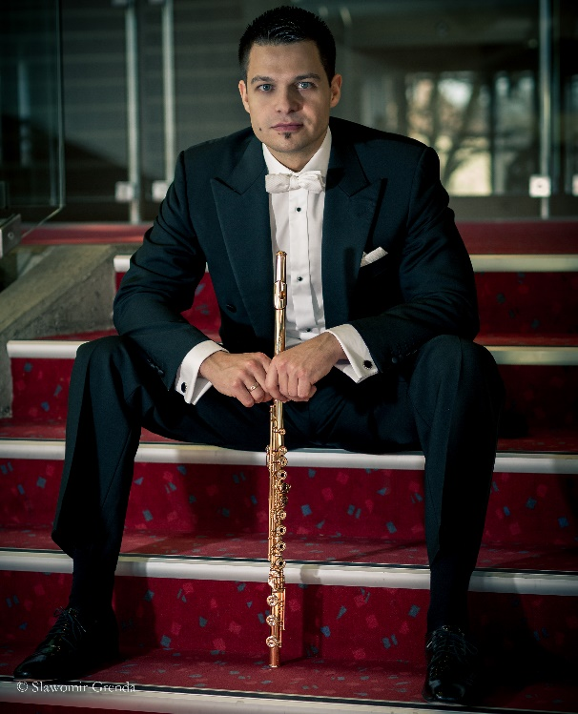

2. 7. – 7. 7. 2025
Glasbena šola / Music School Slovenska Bistrica, Slovenija

Mednarodno priznani flavtist Martin Belič od leta 2007 živi in ustvarja v Münchnu, kjer je asistent solo flavtist Münchenskih filharmonikov. Je tudi docent na Univerzi Leopold Mozart v Augsburgu. Njegovi prvi učitelji so bili profesorji A. Biczkey, K. Škarpa, B. Rojko in V. Ozvatič. Z odliko je diplomiral na Mozarteumu v Salzburgu pri prof. Herti Mergl in prof. Ireni Grafenauer, pri kateri je leta 2007 z odliko magistriral na koncertni smeri, ter vpisal podiplomski študij pri prof. Michaelu Martinu Koflerju.

Je zmagovalec več slovenskih in mednarodnih tekmovanj v Italiji, Avstriji in Nemčiji. Leta 2000 je prejel Zoisovo štipendijo in postal Gallusov varovanec. Je prejemnik plakete Dr. Romana Klasinca in dobitnik štipendije Yehudi Menuhin »Life music now« (2006). Na mednarodnih tekmovanjih Intermusica Birkfeld 2009« in Theobalda Böhma leta 2011 v Münchnu je bil skupni zmagovalec, zdaj je tudi predsednik strokovne žirije tekmovanja Theobalda Böhma. Od leta 2010 je asistent M. M. Koflerja na mednarodnem mojstrskem tečaju v Celovcu in enajst let vodi svojo mednarodno poletno šolo v Slovenski Bistrici. Je tudi docent pri Zvezi bavarskih godb.

Poleg solističnih koncertov in komornih recitalov je snemal in koncertiral še s Simfoničnima orkestroma Slovenske filharmonije in SNG Maribor, Simfoniki RTV Slovenija, Zagrebškimi filharmoniki, madžarskim Mendelssohn Chamber Orchestra, Ensemble Dissonance, Orkestrom Amadeo, idr. Redno deluje kot gost v orkestrih na Bavarskem, v Kölnu, Salzburgu in Würtenbergu.

Založba Gallus je leta 2005 izdala CD »Zelenci« s posnetkom Bizet-Bornejeve Briljantne fantazije na temo »Carmen« z Martinom Beličem, Mariborsko filharmonijo in dirigentom Stefanom Garkovim. Leta 2009 je izšel CD Mladi virtuozi 1 s Simfoniki RTV Slovenija in Koncertom za flavto C. Nielsna. S triom FUOCO je izdal CD Music from the Fire (2011) in nato drugi samostojni CD OPUS s pianistom Ivanom Ferčičem z deli Theobalda Böhma (2018).

Marijan Zlobec je o njem zapisal: »Martin Belič nadaljuje veliko tradicijo slovenskih koncertnih flavtistov v zadnjega pol stoletja – od Borisa Čampe in Irene Grafenauer do sodobnosti – in je eden izmed reprezentantov svetovne koncertne flavte.«

Ob lanskem abonmajskem koncertu SMS z orkestrom Slovenske filharmonije, ki ga je vodil estonski dirigent Olari Elts, je glasbeni kritik Tomaž Gržeta zapisal za časnik Večer: »Martin Belič je prostrano dvorano napolnil s skrbno odmerjenim ravnovesjem tišine in očarljivega, prefinjeno oblikovanega zvena svojega glasbila.«

Ustanova Gallus mu je na Jesenskem Gallusovem Odru izbranih 2023 kot prvemu izmed Gallusovih varovancev podelila naziv Gallusov ambasador.
Internationally renowned flutist Martin Belič has been living and working in Munich since 2007 and is a prominent Slovenian concert musician. He is assistant solo flutist of the Munich Philharmonic Orchestra and assistant professor at the Leopold Mozart University in Augsburg.

In 2003 he graduated with honours from the Mozarteum in Salzburg under Prof. Herta Mergl and Prof. Irena Grafenauer, from whom he received his Master's degree in concert performance in 2007, and completed his postgraduate studies under Prof. Michael Martin Kofler.

He has won several Slovenian and international competitions in Italy, Austria and Germany. He is the recipient of the Yehudi Menuhin "Life music now" scholarship (2006). He was the overall winner of the international competitions "Intermusica Birkfeld 2009" and "Theobald Böhm 2011" in Munich and is now also the President of the jury of the Theobald Böhm Competition.

Since 2010 he has been assistant to Michael Martin Kofler at the International Masterclass in Klagenfurt, and for eleven years he has been running his own International Summer School in Slovenska Bistrica and is a docent at the Bavarian Brass Band Association.

I In addition to solo concerts and chamber recitals, he has recorded and performed as a soloist with the Slovenian Philharmonic and the Zagreb Philharmonic Orchestra, the Symphony Orchestras of RTV Slovenia and of the Slovene National Theatre Maribor, the Hungarian Mendelssohn Chamber Orchestra, Ensemble Dissonance, Amadeo Orchestra, etc. He is a regular guest of orchestras in Bavaria, Cologne, Salzburg and Würtenberg.

In 2005 the Gallus Records released the CD with the Maribor Philharmonic Orchestra. In 2009, the CD "Young Virtuosi 1" was released with the RTV Slovenia Symphony Orchestra. With the trio FUOCO he released in 2011 the CD Music from the Fire and in 2018 solo CD OPUS with pianist Ivan Ferčič with Theobald Böhm’s works.

Marijan Zlobec wrote about him: "Martin Belič continues the great tradition of Slovenian concert flutists over the last half century - from Boris Čampa and Irena Grafenauer to the present day - and is one of the representatives of the world concert flute."

With the Slovenian Philharmonic Orchestra, led by Estonian conductor Olari Elts, music critic Tomaž Gržeta pointed out that "Martin Belič filled the spacious hall with a carefully measured balance of silence and the enchanting, finely crafted sound of his instrument."

The Gallus Foundation awarded him the honorary title of Gallus Ambassador as the first of Gallus' protégés at the Autumn Gallus Stage 2023.
PRIJAVNICA
Ime in priimek udeleženca

Datum in kraj rojstva

Naslov

Telefon: E- mail:
- Želim igrati na zaključnem koncertu
- Ne želim igrati na zaključnem koncertu Predlog programa (navesti naslov in avtorja dela)

Podpis (mladoletnim podpiše eden od staršev)

Cena poletne šole znaša: (5 učnih ur)
- aktivni udeleženec 300 EUR
- pasivni udeleženec 50 EUR

ROK PRIJAVE JE 25. APRIL 2025.
Obvezna priloga – življenjepis.
Ob prijavi je potrebno poravnati 150 EUR prijavnine. Število mest je omejeno.
Izbrane kandidate bomo obvestili v začetku maja.
Prijavnino nakažite na IBAN:
SI56 0201 1001 6061 274
BIC/SWIFT: LJBASI2X, pri NLB Ljubljana
Pri plačilu navedite sklic: SI00 02072025 na naslov: USTANOVA GALLUS, Metelkova 6, 1000 Ljubljana,
s pripisom »MEDNARODNA POLETNA ŠOLA FLAVTA«

Razlika 150,00 EUR se poravna do 23. maja 2025
Potrdilo o plačilu kotizacije pošljite na spodnji e-naslov..

Dodatne informacije: info@ustanova-gallus.si
ravnateljica@glasbena-sb.si

